Kines 442: Bodies, Culture & Society
Course Description:
What is a body? Is there such a thing as “the” body? How are bodies produced? What do they represent? Who gets to represent them? We will examine bodies in history, in particular cultural contexts, in international and national forums. Our readings will vary widely to include anthropological, historical, psychological and sociological perspectives. We will focus our assigned projects on exercise, health and sport practices in general and on the University of Illinois campus in particular. This course is connected to the Ethnography of the University Initiative.

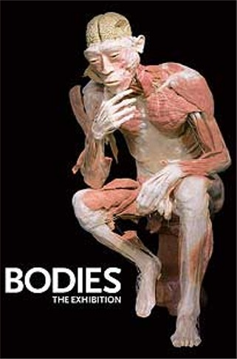

Contact Information
Assistant Professor Melissa Littlefield,
Email: mml@uiuc.edu
Phone: 244-1835 (Freer)
Offices: 354 Freer; 102d English Bldg
Office Hours: MW 3:30-4:30

Required Texts
--The Body in Society: An Introduction, Alexandra Howson
--Body Work, Debra Gimlin
--Electronic Readings on Moodle

Objectives
By the end of this course, you should be able to:
- Critically analyze definitions of the body
- Create logical arguments for a particular position, definition, theory or hypothesis
- Understand and discuss issues of race, class, disability, gender and sexuality
- Recognize and differentiate between different theories of the body
- Perform basic ethnographic research

**Please Note: If you anticipate needing any type of accommodation in this course or have questions about physical access, please let me know (via email or after class) as soon as possible.

****Students cannot receive a passing grade until all of their IRB (Institutional Review Board) forms have been handed in to me or Tim McDonough, EUI Coordinator****

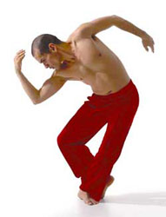
Course Requirements

I will expect regular attendance and energetic class participation. In order to participate, you’ll need to do the reading assigned for each class. This course is not only reading intensive, but writing intensive so plan your time carefully in order to keep up. Quality of class participation (individually and within your groups) and attendance will count toward your participation grade. All assignments must be handed in on time. Late work will normally be docked ½ of a letter grade per weekday, unless you receive my approval for an extension before the due date.

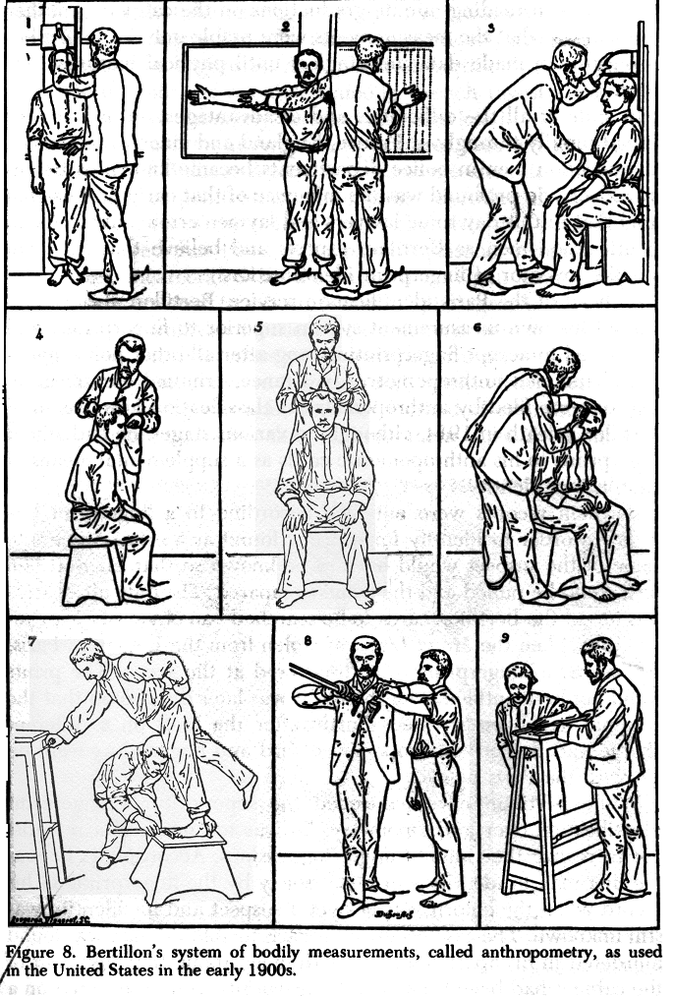

Group Work
Please note that for a portion of this course, you will be working with and responsible to a smaller group of students. Group work will include writing a revised proposal, writing an analysis, and presenting your findings for the Bodies on Campus Project.

Attendance
“Regular class attendance is expected of all students at the University.”
(Student Code 5:1)

This course is structured around participation and discussion in the classroom and in our online forum. Both depend on your scrupulous and conscientious attention to the assigned reading. I want to hear each and every one of you speaking in class—and will encourage you to do so. I expect you to be active and energetic participants. Regular attendance and timely completion of reading assignments are required and crucial to your success in and enjoyment of this course.

Because we meet just once a week and a large portion of our course is structured around group work and the EOTU Project, I expect each of you to be present every week. I do understand that from time to time emergencies happen; therefore I will allow one unexcused absence—please use it wisely. Your grade will drop ½ letter grade for each additional unexcused absence.

Office Conferences See me when you have questions about an assignment, when you would like to try out some ideas before a document is due, or when you have questions about lectures/class discussions. You should also see me to get help with particular writing problems.

Grades

To pass this course you must satisfactorily meet all requirements. Grades on individual assignments are meant to reflect the quality of your work. When figuring your overall grade, I will use the following formula:

% | What? | Where? | When?
5%  5% | Participation/Attendance/In class work  Group Evaluation/Participation | In Class  Online | Every Day!  4/29
10% | Reading Responses x 2 | In class | 1/22
10% | Proposal: Project Questions and Plan  **Includes (GROUP) Revised Project Proposal | Moodle/In class  Moodle | 2/12  2/26
15% | Bodies on Campus Project  Includes:  --DATA: Observations  *OR—DATA: Archive Report  *OR—DATA: Interviews  *IRB Forms Due with interviews | Moodle | I: 3/11  II: 4/1
30% | --Discussion/Critical Analysis (GROUP)  --Abstract and Keywords (GROUP) | Moodle | 4/15
15% | Meta Analysis  Includes:  --Reflection  --EUI Link  --About the Author  --Recommendations | Moodle | 4/22
10% | Project Presentation/ (GROUP)  Conference Presentation | In Class | 4/29

Plagiarism
The University of Illinois has a strict code for academic integrity set out in "Article 1, Part 4" of the University Student Code. According to the code, using material from an uncited source as if it were your own is an academic violation and not to be tolerated. (It is tantamount to a theft of ideas.) Ignorance about the code will not serve as an excuse for infractions. For precise details about what "plagiarism" means and how it is dealt with, please consult the following web address: http://www.admin.uiuc.edu/policy/code/ If, for some reason, you cannot use the internet, you may ask me for a paper copy of Article 1, Part 4.
Kines 442 Syllabus: Spring 2008
Assignments are listed on the day they are DUE; however, the following schedule
is subject to change--I will post full assignments each day in class. TBA=to be announced

Date | Topic | Reading | Assignments
1/15 | Introductions
1/22 | Definitions  Training and Access | Body in Society Intro and Chapter 1 | Response Paper Due  **Group A
1/29 | Understanding Bodies | Body in Society Chapter 3 & 5 | Response Paper Due  **Group B
2/5 | Understanding Bodies  Making the Pitch | Body in Society Chapters 4 and 6 | Bring Three Possible Project Ideas
2/12 | Pitching the Idea |  | Proposal Presentations
2/19 | Visit to the Archives | --Body in Society Chapter 2  --UI Archives Tutorial  http://www.library.uiuc.edu/archives/slc/
2/26 | Fieldnotes | --Emerson “Fieldnotes”  --Emerson “Jotting”  --Becker Tricks of the Trade:  “Imagery.” 46-57  “Sampling.” 67-108 | Revised Proposal Due
3/4 | Interviews | --Body Work: Chapters 1 & 3  OPTIONAL: Body Work Introduction | Response Paper Due  **Group A
3/11 | Ethnography | --Weis “Interviewing” 61-119  --Emerson “From Field to Desk”  --Stacey, “Can there be a feminist  ethnography?” 111-119  --Boyer “University as Ecosystem” | DATA I Due (Moodle)
3/18 | SPRING BREAK | SPRING BREAK | SPRING BREAK
3/25 |  | Body Work: Chapters 2, 4 & Concl. | Response Paper Due  **Group B
4/1 | Race | --Jonathan Lethem, “Vanilla Dunk”  --Brett St. Louis, “Sport, Genetics and the Natural Athlete” | DATAII Due (Moodle)
4/8 | Group Work Day | Reading TBA
4/15 | Disability | Erik Weihenmayer  film and discussion  “Blind to Failure”  “Touch the Top of the World” | Bodies on Campus Analysis Due (Moodle)
4/22 | Education | --Jose van Dijk “Body Worlds”  --NYT “Body Worlds” article  --Visit “Bodies, the Exhibit”  http://www.bodiestheexhibition.com/bodies.html | Meta Analysis  Elements Due (Moodle)
4/29 | Wrap-up! |  | Bodies on Campus  Presentations Due



